**LAB – 10(Assignment-6)**

Student ID: AF0416803

Student Name: Navneet P

**Q1. Write a function in python to read the content from a text file "ABC.txt" line by line and display the same on screen.**

Solution:

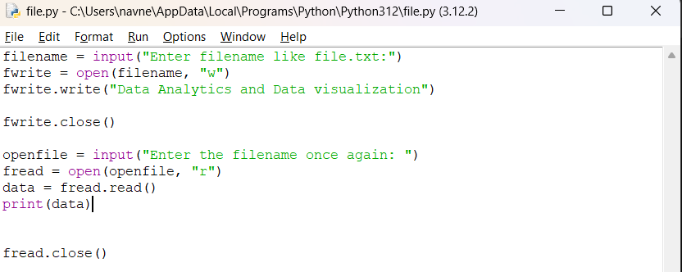

First, a file is created with filename being an input from the user, then opened in write mode and closed. Again, we open the same file in read mode and see the data being displayed.

Output:

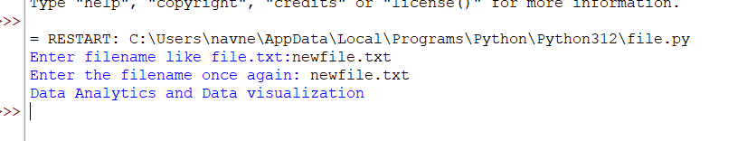

**Q2. Write a function in Python to count and display the total number of words in a text file “ABC.txt”**

Solution:

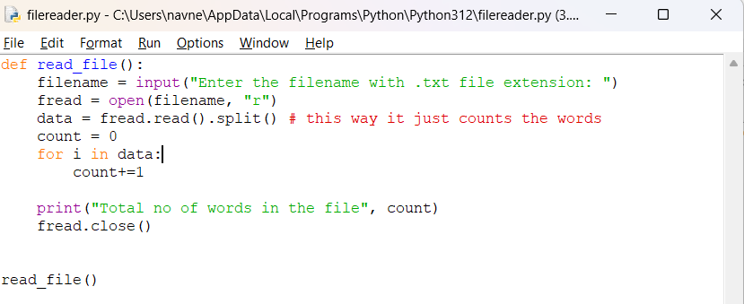

Output:

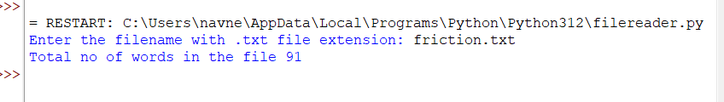

**Q3. Write a function in Python to count uppercase character in a text file “ABC.txt”**

Solution: 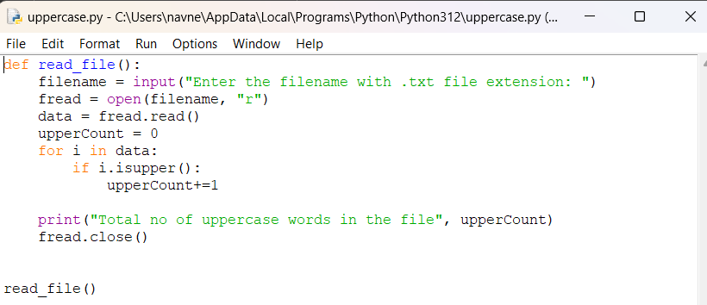

Output:

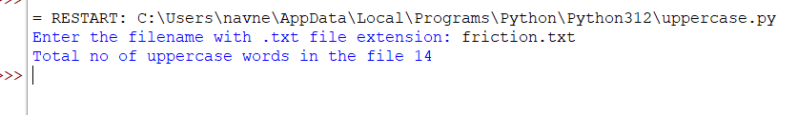

**Q4. Write a function display_words() in python to read lines from a text file "story.txt", and display those words, which are less than 4 characters.**

Solution:

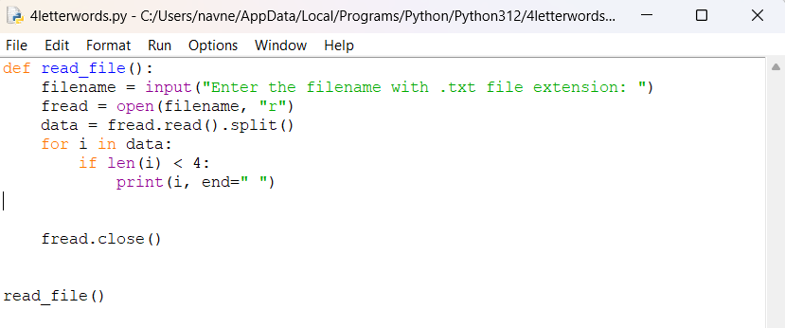

Output:

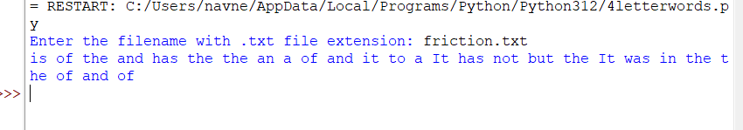

**File used/generated: friction.txt**

**Contents of friction.txt**

Lorem Ipsum is simply dummy text of the printing and typesetting industry. Lorem Ipsum has been the industry's standard dummy text ever since the 1500s, when an unknown printer took a galley of type and scrambled it to make a type specimen book. It has survived not only five centuries, but also the leap into electronic typesetting, remaining essentially unchanged. It was popularised in the 1960s with the release of Letraset sheets containing Lorem Ipsum passages, and more recently with desktop publishing software like Aldus PageMaker including versions of Lorem Ipsum.